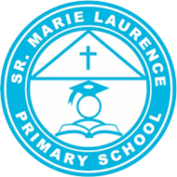
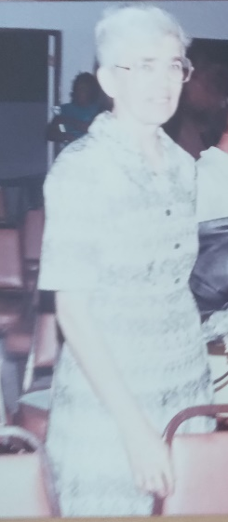
The Sister Marie Laurence School was founded in 1988, when six groups from the St. Joseph School were designated as the new school. The school was named after Sister Marie Laurence Teeuwen, a revered member of the Dominican Sisters who dedicated many years of service to Catholic education on Sint Maarten. Born in Tegelen, Holland, on October 6, 1929, Sister Marie Laurence worked as a teacher in the Netherlands for 14 years before joining the Dominican Sisters on Sint Maarten. She later served as the President of the Foundation Catholic Education for the Windward Islands from 1977 to 1990.
Initially, the new school shared the premises of the St. Joseph School, which now houses the Tourism Bureau. However, after six years, the new long-awaited school building in Middle Region was ready. The journey to secure land for the school was not easy; the School Board and the school faced significant challenges due to the lack of available land. Finally, the family of Mr. Vacquelin Conner (former Island Secretary) graciously agreed to lease a piece of land on Middle Region Road to the School Board. In honor of the family, the primary school was named after Sister Marie Laurence, and the kindergarten was named after one of our local nuns, Sister Modeste Conner.
On February 23, 1994, the school officially moved from the old building on Front Street to the new premises in Middle Region. The school became a true community hub with the completion of a multipurpose playground, giving back a ball field to the youth. Many individuals and organizations helped make this dream a reality, including the Juliana Welzijn Fonds for their financial support and Mr. Henri Brookson for leading the project. In 1998, Mr. Brookson and his team introduced a new educational concept, Experiential Education, after receiving training in the Netherlands. Both teachers and students embraced this innovative approach.
Throughout the years, school leadership changed hands. Mr. Henri Brookson was the first principal of the school. In 1998, he was called to serve as the Deputy Minister Plenipotentiary for Sint Maarten in the Netherlands. Mrs. Duana Richardson then led the school for two years until Mr. Brookson returned. Leadership later transitioned to Mrs. Lilia Aventurin-Hodge, followed by Mrs. Vivian Roberts, Mrs. Karen Wattley, and currently Mrs. Amaris Slac, who oversees not only the school but also the Community School.
In 2010, a special program, the Individual Education (IE) program, was introduced at the Sister Marie Laurence School for children with behavioral challenges. It included two classes: one with Dutch as the language of instruction, and the other with English. This program ran until November 2022.
In the 2014/2015 academic year, English was introduced as the language of instruction for students in Group 1. The other classes continued using Dutch until the language transition was fully phased out in the 2020/2021 academic year.
The school has faced its share of challenges. After Hurricane Irma in 2017, the school building was damaged and vandalized. As a result, the school was relocated in 2018 to a temporary location between the Sister Magda Primary School and the St. Dominic Primary School. In 2022, all classes, Groups 1 through 8, were housed together at the St. Dominic Primary School, while the community awaits the reconstruction of the original building in Middle Region.
The Sister Marie Laurence Primary School continues to be a place where students, teachers, and the community come together, embracing change while staying true to the vision of its

